**CREATIVE to DEV BRIEF**

**Project Title: VOD Prelander - CBS App**

**Brand Name: CBS**

**Date:** 27/6/2018

**Due date:**

**PROJECT OBJECTIVE**

1. **Specific Project Goals:**

Prepare new pre lander to VOD/Streaming apps offers before their registration/install page.

1. **Audience:**

Language: English

**Product**

* **Required Product**

pre landing page

* **Device**

Device: desktop, tablet, Mobile

responsive: Yes - fit all mobile device

* **User flow**
* Click the button: “Continue to watch for free”.
* User redirected to the offer LP - destination URL
* **Technical requirements**

Forward the following URL parameters from prelander URL to destination URLs:

[**tt_aff_clickid**=@@CLIENT-ID@@&**tt_sub_aff**=@@CLIENT-DB-ID@@&**tt_app_name**=@@REF@@](https://clk.taptica.com/aff_c?ver=bulk&tt_ls=b&offer_id=33668021&tt_appid=com.cbs.app&aff_id=2232252&tt_aff_clickid=DUMMY&tt_sub_aff=%40%40CLIENT-DB-ID%40%40&tt_app_name=%40%40REF%40%40)

To be hosted under:

[http://movies4all.online/gen/pr4/tap_cbs/?**p=**](http://movies4all.online/gen/pr3/flx_en/?p=if1&clickid=DUMMY&pubid=%40%40CLIENT-DB-ID%40%40)@@parameter@@&[tt_aff_clickid=@@CLIENT-ID@@&tt_sub_aff=@@CLIENT-DB-ID@@&tt_app_name=@@REF@@](https://clk.taptica.com/aff_c?ver=bulk&tt_ls=b&offer_id=33668021&tt_appid=com.cbs.app&aff_id=2232252&tt_aff_clickid=DUMMY&tt_sub_aff=%40%40CLIENT-DB-ID%40%40&tt_app_name=%40%40REF%40%40)

Destination URL:

* There’s a need to pass parameters from prelander URL query string to each destination URL. See Complete Prelander & Destination URLs here:

|  |  |
| --- | --- |
| **Identifier 'P' (**parameter**) Value** | Destination URL |
| cbsfean | [https://clk.taptica.com/aff_c?ver=bulk&tt_ls=b&offer_id=33668021&tt_appid=com.cbs.app&aff_id=2232252&tt_aff_clickid=@@CLIENT-ID@@&tt_sub_aff=@@CLIENT-DB-ID@@&tt_app_name=@@REF@@](https://clk.taptica.com/aff_c?ver=bulk&tt_ls=b&offer_id=33668021&tt_appid=com.cbs.app&aff_id=2232252&tt_aff_clickid=DUMMY&tt_sub_aff=%40%40CLIENT-DB-ID%40%40&tt_app_name=%40%40REF%40%40) |
| cbsaaan | [https://clk.taptica.com/aff_c?ver=bulk&tt_ls=b&offer_id=34540052&tt_appid=com.cbs.ca&aff_id=2232252&tt_aff_clickid=@@CLIENT-ID@@&tt_sub_aff=@@CLIENT-DB-ID@@&tt_app_name=@@REF@@](https://clk.taptica.com/aff_c?ver=bulk&tt_ls=b&offer_id=34540052&tt_appid=com.cbs.ca&aff_id=2232252&tt_aff_clickid=DUMMY&tt_sub_aff=%40%40CLIENT-DB-ID%40%40&tt_app_name=%40%40REF%40%40) |
| cbshsan | h[ttps://clk.taptica.com/aff_c?ver=bulk&tt_ls=b&offer_id=34714532&tt_appid=com.cbs.app&aff_id=2232252&tt_aff_clickid=@@CLIENT-ID@@&tt_sub_aff=@@CLIENT-DB-ID@@&tt_app_name=@@REF@@](https://clk.taptica.com/aff_c?ver=bulk&tt_ls=b&offer_id=34714532&tt_appid=com.cbs.app&aff_id=2232252&tt_aff_clickid=DUMMY&tt_sub_aff=%40%40CLIENT-DB-ID%40%40&tt_app_name=%40%40REF%40%40) |
| cbsfeios | [https://clk.taptica.com/aff_c?ver=bulk&tt_ls=b&offer_id=33667956&tt_appid=530168168&aff_id=2232252&tt_aff_clickid=@@CLIENT-ID@@&tt_sub_aff=@@CLIENT-DB-ID@@&tt_app_name=@@REF@@](https://clk.taptica.com/aff_c?ver=bulk&tt_ls=b&offer_id=33667956&tt_appid=530168168&aff_id=2232252&tt_aff_clickid=DUMMY&tt_sub_aff=%40%40CLIENT-DB-ID%40%40&tt_app_name=%40%40REF%40%40) |
| cbsaaios | [https://clk.taptica.com/aff_c?ver=bulk&tt_ls=b&offer_id=34540070&tt_appid=1340650234&aff_id=2232252&tt_aff_clickid=@@CLIENT-ID@@&tt_sub_aff=@@CLIENT-DB-ID@@&tt_app_name=@@REF@@](https://clk.taptica.com/aff_c?ver=bulk&tt_ls=b&offer_id=34540070&tt_appid=1340650234&aff_id=2232252&tt_aff_clickid=DUMMY&tt_sub_aff=%40%40CLIENT-DB-ID%40%40&tt_app_name=%40%40REF%40%40) |
| cbshsios | [https://clk.taptica.com/aff_c?ver=bulk&tt_ls=b&offer_id=34714523&tt_appid=530168168&aff_id=2232252&tt_aff_clickid=@@CLIENT-ID@@&tt_sub_aff=@@CLIENT-DB-ID@@&tt_app_name=@@REF@@](https://clk.taptica.com/aff_c?ver=bulk&tt_ls=b&offer_id=34714523&tt_appid=530168168&aff_id=2232252&tt_aff_clickid=DUMMY&tt_sub_aff=%40%40CLIENT-DB-ID%40%40&tt_app_name=%40%40REF%40%40) |

* **Mockup**

**Desktop:**

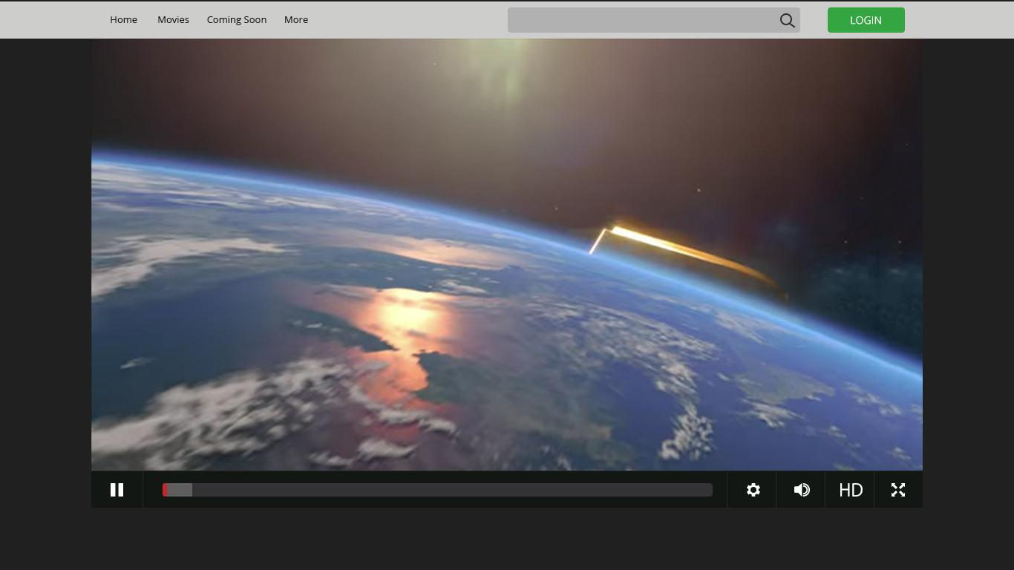

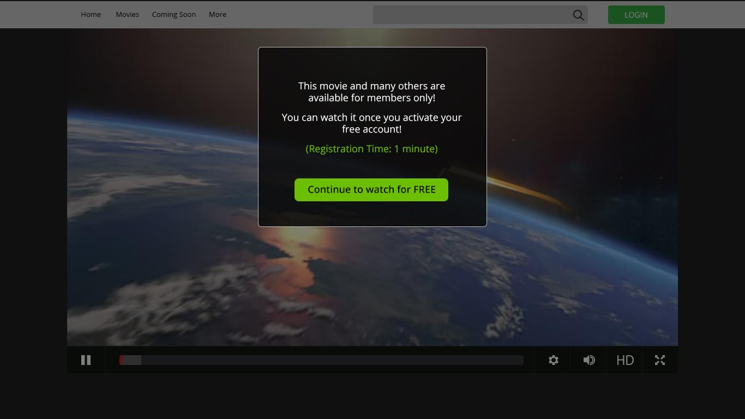

**Tablet:**

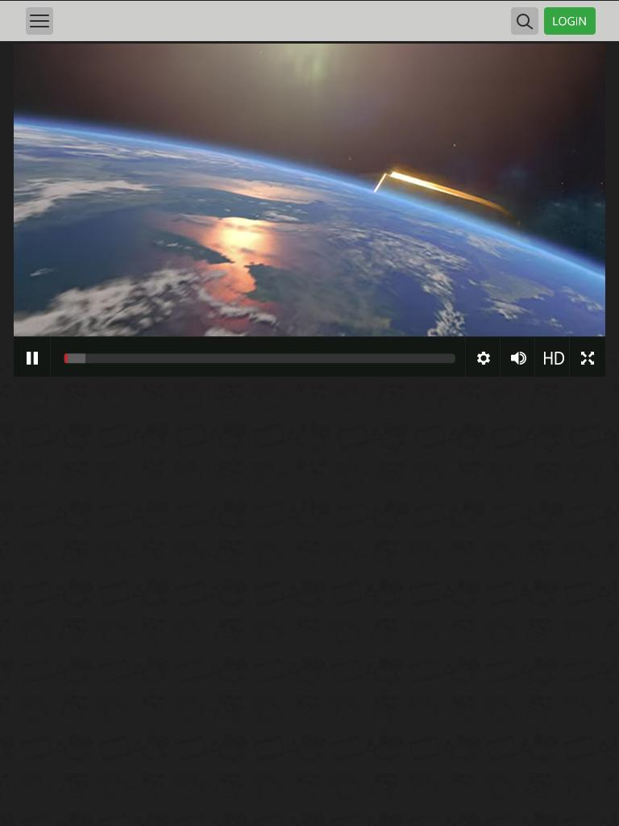

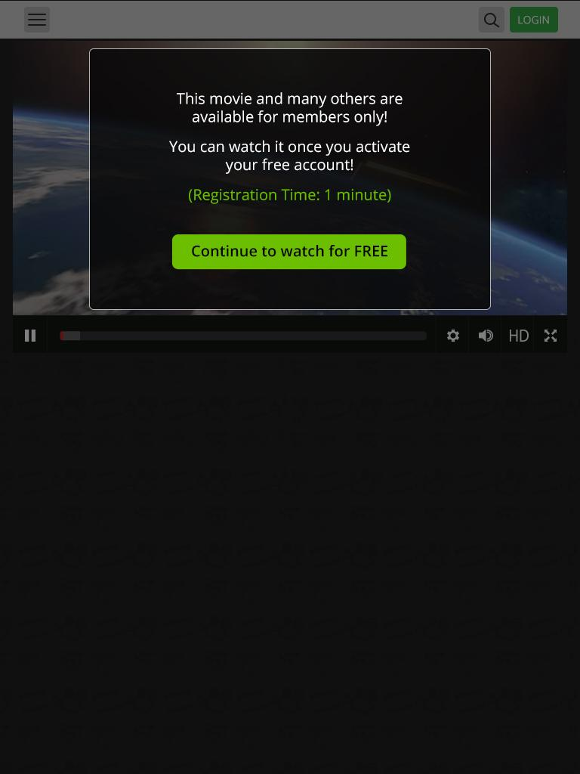

**Mobile:**

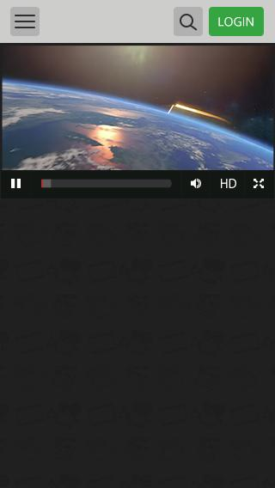

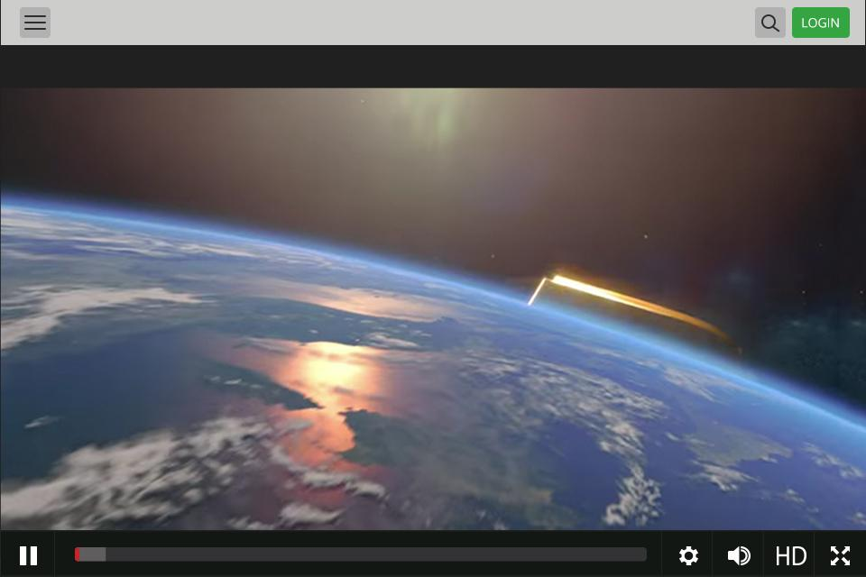



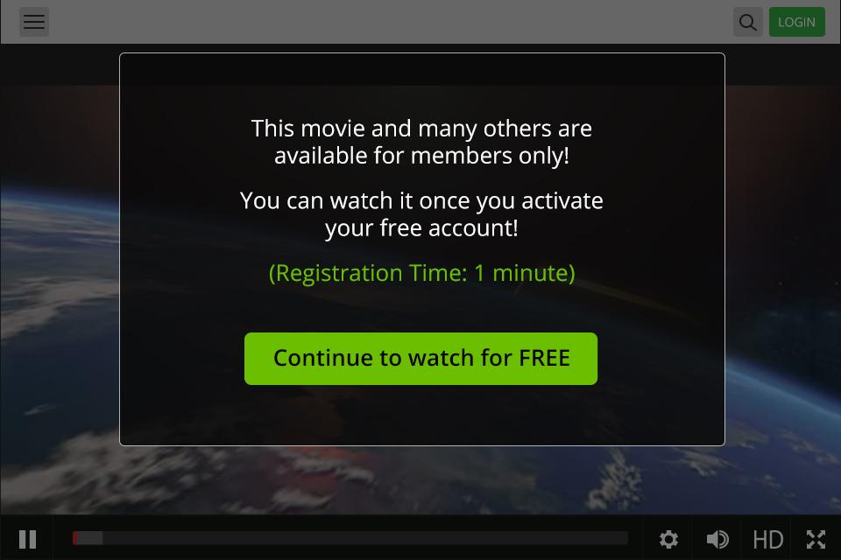

**Links to Spec:**

**Desktop:** [**https://adobe.ly/2KlRXtc**](https://adobe.ly/2KlRXtc)

**Tablet:**[**https://adobe.ly/2N2VHl4**](https://adobe.ly/2N2VHl4)

**Mobile:** [**https://adobe.ly/2tyihtO**](https://adobe.ly/2tyihtO)[**https://adobe.ly/2Klwock**](https://adobe.ly/2Klwock)

**Flow & functionality:**

- Header - static, no mouse-hover, no clicks

- When the page opens, the video starts playing automatically (Desktop + iOS - 6 sec - mp4 movie/ Android - 3 sec - gif movie).

- As the video begins to load, a "gray stripe" inside the player, it is loaded with relatively large jumps (like a youtube). Red Stripe begins to move relatively slowly with a video.

- After 3 seconds the video plays, pop appears. All pop is clicked. By clicking on it, a user moves to a new page that opens in a new tab.

- The video continues playing for 3 seconds once pop pops up (in the layer behind it) - only in desktop + iOS

- After 6/3 seconds a video stops, a red stripe stops, and a "gray stripe" continues to load until it reaches the end. Pop (if not pressed) remains.

**Text:**

This movie and many others are available for members only!

You can watch it once you activate your free account!

(Registration Time: 1 minute)

Button Text:   
Continue to watch for free